|  |  |  |  |  |  |  |  |
| --- | --- | --- | --- | --- | --- | --- | --- |
| Test Report Astronomical Processing | | | | | | | |
| Project Name: Astro Processing | | | Test Type: | | | | |
| Description: Testing different inputs | | | Date: 13/10/2021 | | | | |
| Developer: Rishon | | | Tester: Brody | | | | |
| Test Case # | Test Case Name | Test Steps | | Test Data | Expected Results | Evidence | Pass / Fail |
| 1 | Average button works and textbox display the result to only 2 decimals | Click fill button then  click average button | |  | Decimal number with only 2 decimal places | Screenshot 1 | Pass |
| 2 | Mid-Extreme works and displays the result to only 2 decimal places | Click fill button then  click mid-extreme button | |  | Decimal number with only 2 decimal places | Screenshot 2 | Pass |
| 3 | Sequential search is working properly (output ‘found’ for successful search) | Fill data button, enter number to search for, click sequential search button | |  | Message output: ‘Found’  Item Highlighted | Screenshot 3 | Pass |
| 4 | Sequential search is working properly (output ‘not found’ for unsuccessful search) | Fill data button, enter number to search for, click sequential search button | |  | Message output:  ‘Not found’ | Screenshot 4 | Pass |
| 5 | Range works properly | Fill data button, click range | |  | Range displayed in output textbox | Screenshot 5 | Pass |
| 6 | Mode works properly | Fill data button, click mode | |  | Mode displayed in output textbox | Screenshot 6 | Pass |
| 7 | Tool tips pop-up on buttons when cursor hovers over | Hover over any button | |  | Tool tip pops up explaining the button’s function | Screenshot 7 | Pass |
| 8 | Error message when text box is empty (for sequential search) | Click sequential search while the input text box is empty | |  | Displays error message saying that the textbox is empty | Screenshot 8 | Pass |
|  |  |  | |  |  |  |  |
|  |  |  | |  |  |  |  |

**Test 1 Screenshot evidence:**

Below: Average works and is rounded to two decimal places

**Test 2 Screenshot evidence:**

Below: Mid-Extreme works and is rounded to one decimal place (still acceptable)

**Test 3 Screenshot Evidence:**

Below: Button to initiate a Sequential search and return ‘found’ message (a successful search)

**Test 4 Screenshot evidence:**

Below: Unsuccessful search outputs ‘not found’

**Test 5 Screenshot Evidence**

Below: Range is working

**Test 6 Screenshot Evidence:**

Below: Mode is working

**Test 7 Screenshot Evidence:**

Below: Tool tip pops up when cursor hovers over any button

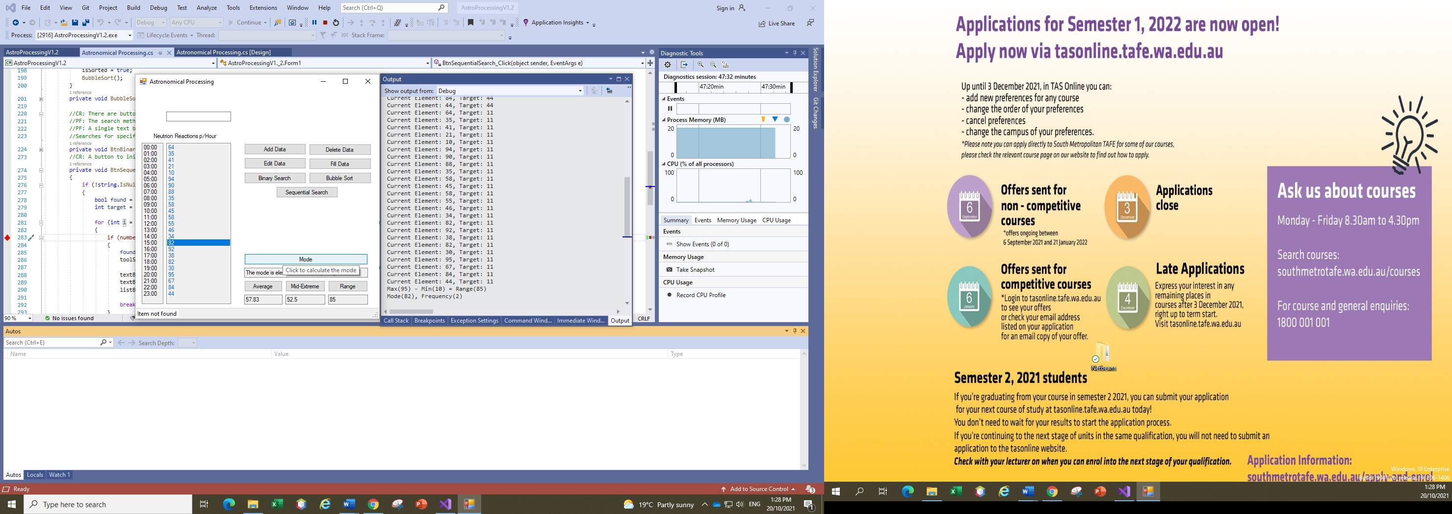

**Test 8 Screenshot Evidence:**

Below: Error message displays ‘text box is empty’ when sequential search is clicked, and the text box is empty

